PROJECT DESIGN PHASE

Date | 02-11-2025
Team ID | NM2025TMFD07309
Project name | Laptop Request Catalog item Using Service Now

Introduction to Design Phase:
The Design Phase focuses on translating the business requirements for the Laptop Request Catalog Item into a detailed, functional, and technical solution within the ServiceNow platform. This phase ensures that the catalog item is intuitive, user-friendly, and aligned with organizational policies and IT service management (ITSM) standards.

STEPS:
1.Creation of new update set:
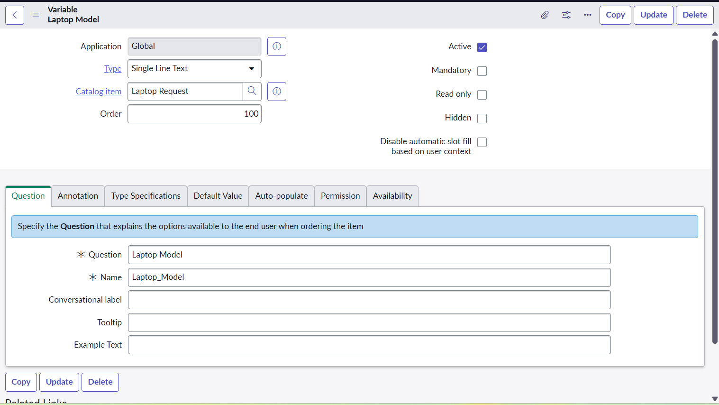
Go to All >> In the filter search for Local Update set > click on New.
Enter the Details in laptop
2.Table creation:
Catalog Items in table:
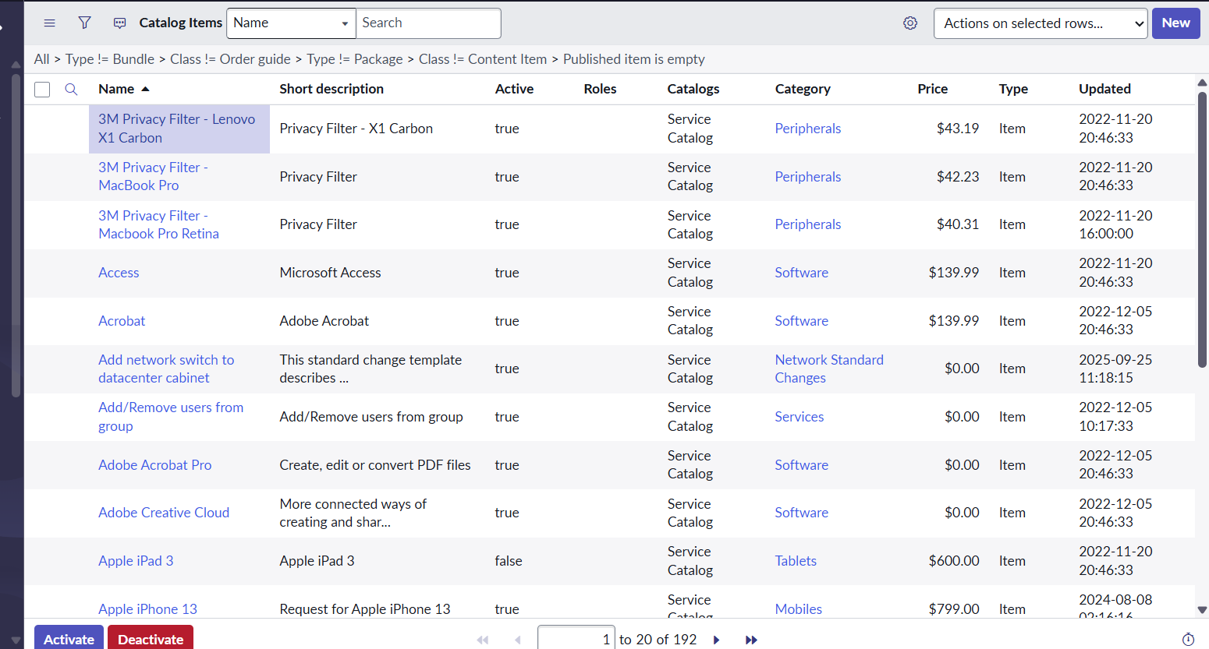
Laptop Request table:

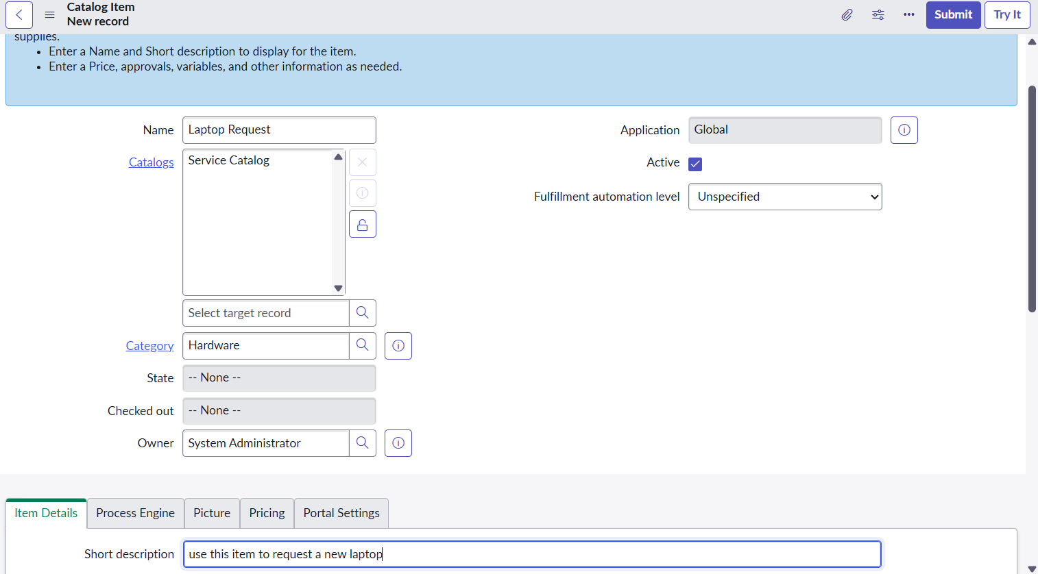

3. Add Variables:
- Go to All >> In the filter search for Relationships >> Open Relationships
- Click on New.
- Enter the details:

Variables :Laptop Model
Type: Single line text
Name: laptop_model
Order:100

Variables : Accessories Details
Type: Multi line text
Name:accessories_details
Order:400
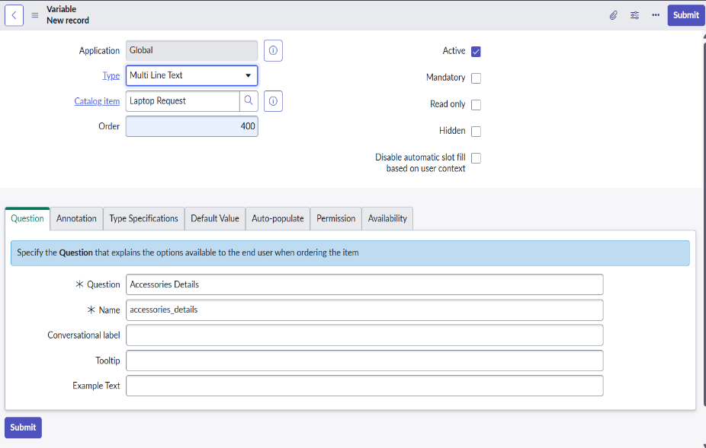

4.Click Save

4.Creation of Business Rules:
- Go to All >> In the filter search for Service catalog.
- Under catalog Definition Laptop Request then click on New.
- Enter the Details:

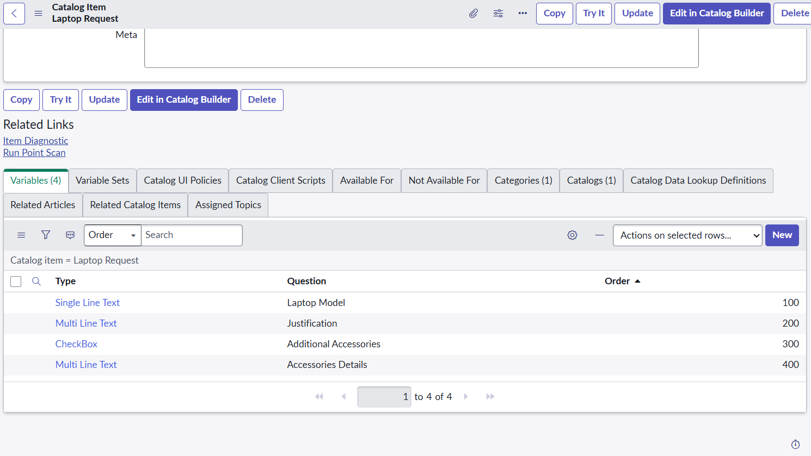
Creation of Ui action:
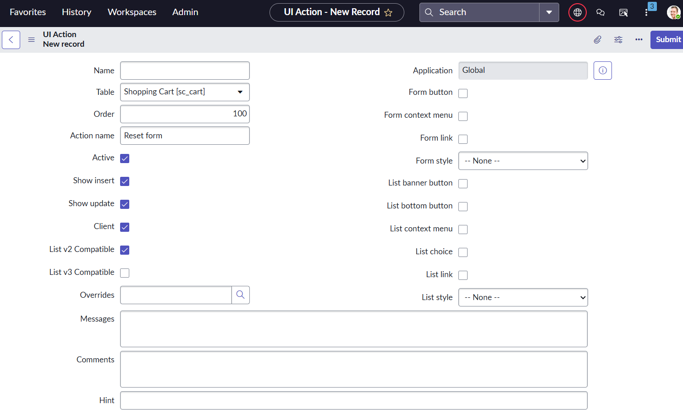

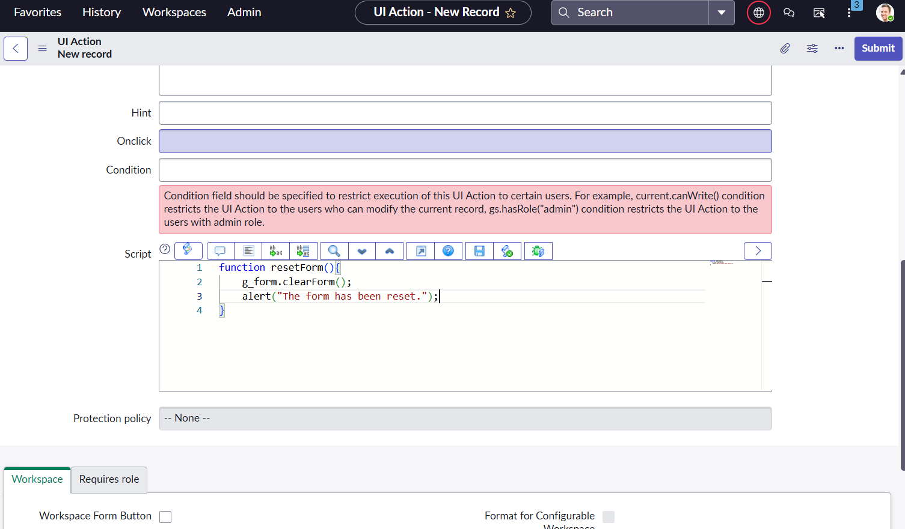

Conclusion of Design Phase:

The completion of the Design Phase marks a critical milestone in the development of the Laptop Request Catalog Item within ServiceNow. Through careful analysis and design, all functional and technical requirements have been translated into a detailed blueprint that ensures a seamless and efficient laptop request process for end users and IT teams alike

